

OpenCalais PHP Demo

Installation & User Guide



Version: 2
Date: 25-September-2008
© 2008 wwbuzz Ltd. Proprietary & Confidential

1. Introduction 3
1.1. Purpose 3
1.2. Background 3
1.3. Scope 3
1.4. Change History 3
1.4.1. From v1 to v2 3
2. Installation 4
2.1. Step 1 – Unpack 4
2.2. Step 2 – Upload 4
2.3. Step 3 – JSON Pear Package 4
2.3.1. Step 3.1 – Installing in PEAR directory 4
2.3.2. Step 3.2 – (Alternative) Installing with Demo 4
2.4. Step 4 - Calais API Key 4
2.5. DONE 4
2.6. Troubleshooting 4
3. User Guide 5
3.1. Entry Page 5
3.2. Document Viewer Style 6
3.3. JSON 7
3.4. Start Over 8

Introduction
This section provides introductory information.

Purpose
This document guides the reader through the installation & use of the OpenCalais PHP Demo. The demo illustrates ClearForest’s OpenCalais Web service, and uses PHP as the server-side language.

Background
The OpenCalais Web service allows users to submit text and retrieve rich semantic metadata following analysis of the text. The OpenCalais PHP Demo illustrates the use of the Web service through PHP.

Scope
This guide provides installation instructions for deploying the demo on a Web server. It also provides a user guide for demo users.

Change History
This section lists changes in the document’s history.

From v1 to v2
- Added section on the configuration of the key.php file (see Step 4 - Calais API KeyStep 4 - Calais API Key)

Installation
This section walks you through the installation of the demo on a Web server.

Step 1 – Unpack
The delivered package is provided as a zip file. Unpack it to a local directory on your machine. This directory will be referred to as demodir below.

Step 2 – Upload
Upload the contents of demodir/src/public to a public directory on your Web server (e.g. C:\Program Files\Apache Software Foundation\Apache2.2\htdocs\calaisPHPDemo). Note that this step may take some time depending on your connection speed.

The public directory you chose will be referred to as publicdemodir below.

Step 3 – JSON Pear Package
This step depends on whether you have access to the PEAR extensions directory on your Web server. If you do, follow step 3.1. If you don’t or do not know, follow step 3.2.

Step 3.1 – Installing in PEAR directory
Upload the file demodir/src/pear/JSON.php to your PEAR extensions directory on the Web server (e.g. C:\php\PEAR).

Step 3.2 – (Alternative) Installing with Demo
Upload the file demodir/src/pear/JSON.php to publicdemodir.

Step 4 - Calais API Key
The single value you need to configure is your Calais API key. To obtain an API key visit http://www.opencalais.com.

Open the file publiddemodir/key.php in a text editor. Replace the text your-api-key-goes-here with your Calais API key (be sure to leave the quotation marks in place).

DONE
Your demo is now accessible on your Web site. Call:
- CalaisPHPDemo.html to see the demo
- ViewerStandard/CalaisViewer.html to see the standard Calais Viewer with an invocation of the API via PHP

Troubleshooting
There are several prerequisites that are not covered in this installation guide:
- Your Web server must support PHP version 4.2 or higher
- Your Web server’s PHP curl extension must be enabled (see php.ini)

User Guide
This section explains how to use the OpenCalais PHP Demo.

Note that use of the standard Calais Viewer is identical to the use of the original Calais Viewer. There are, therefore, no explanations for the standard Calais Viewer.

Entry Page
The following page is displayed when the demo URL is called in a Web browser.

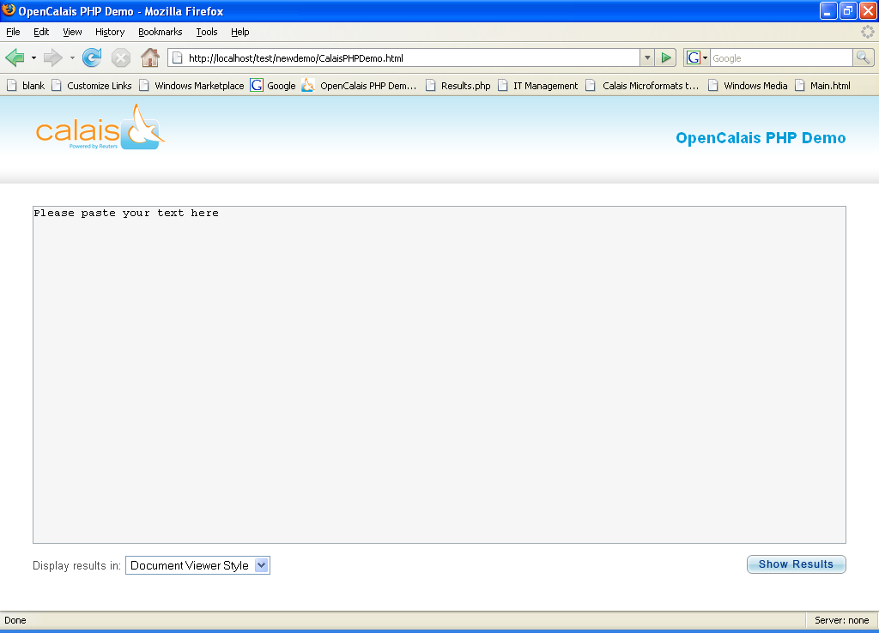

Paste the text you want to analyze into the large text area.

Use the ‘Display results in:’ dropdown box to select the output format:
- Document Viewer Style: The output will be presented with highlighting as in the original Calais Viewer’s body
- JSON: The output will be presented in JavaScript Object Notation.

Click the ‘Show Results’ button.

Document Viewer Style
If you selected the Document Viewer Style output format you will see a page similar to the following:
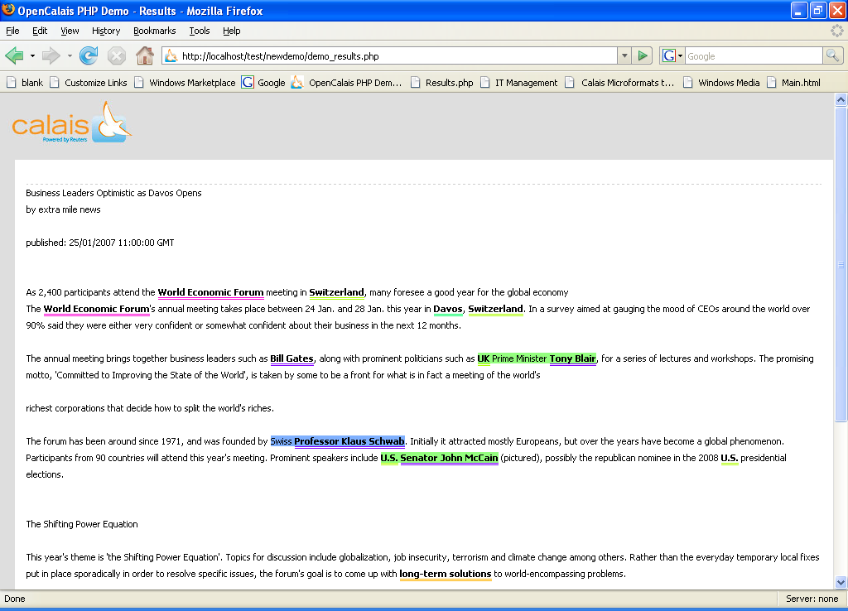

Move your mouse over one of the highlighted terms and you will see a tooltip, as in the following example:
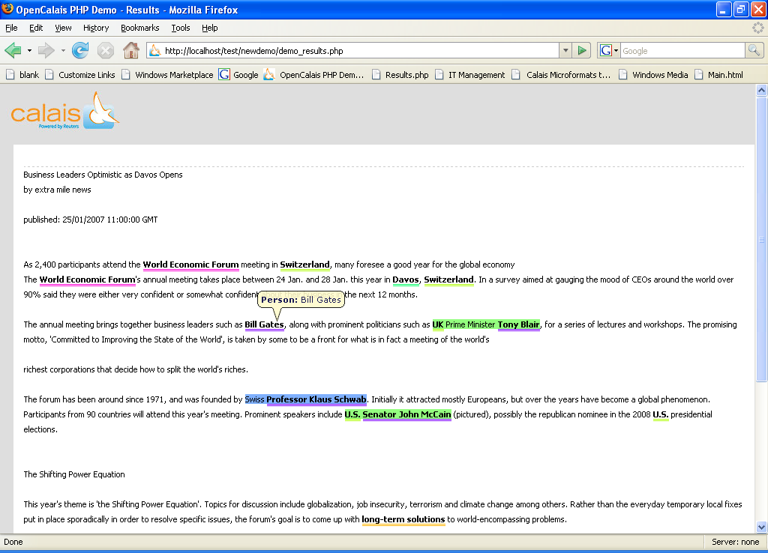

JSON
If you selected the JSON output format you will see a page similar to the following:
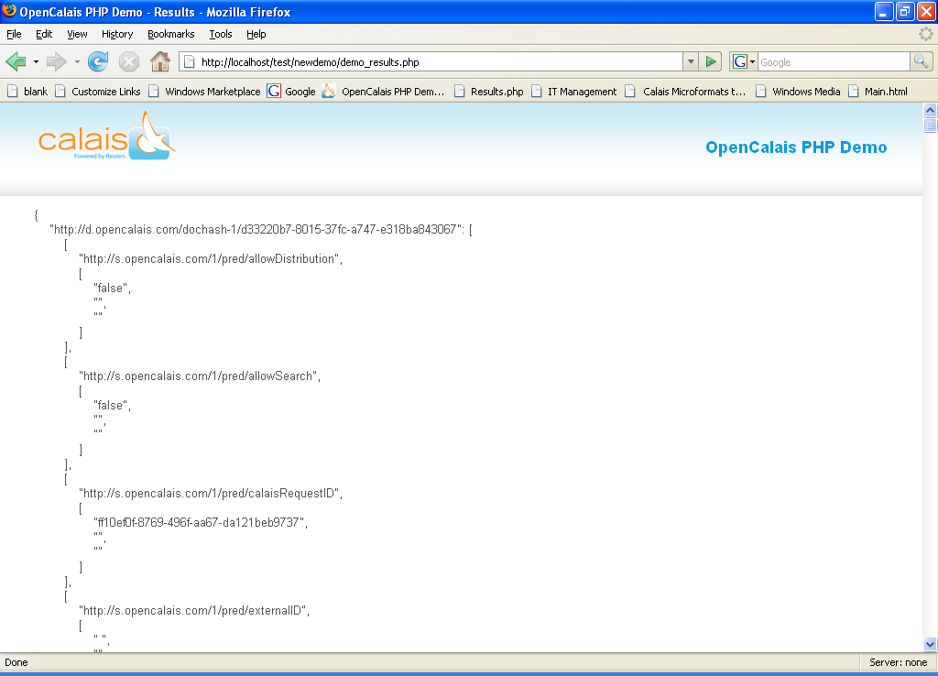

Start Over
In order to start again click the Back button on your browser to return to the entry page.

